HEADER:

9512-JP COLLEGE OF ENGINEERING, Ayikudi,

Department of electronics and communication engineering

Public Transport Optimization-4

Team members:

Sivasakthi velan.k : [sivasakthivelan311202@gmail.com](mailto:sivasakthivelan311202@gmail.com)

Aswinth.S : [aswinth3052003@gmail.com](mailto:aswinth3052003@gmail.com)

Balasurya.A : [suriyakalai24@gmail.com](mailto:suriyakalai24@gmail.com)

Vignesh.R : [rvigneshece27@gmail.com](mailto:rvigneshece27@gmail.com)

Sheik basith. S : [sheikbasith468@gmail.com](mailto:sheikbasith468@gmail.com)

1. IoT Devices and Data Collection:

Utilize IoT devices like GPS trackers, sensors, or simulated data sources for a student project.

Simulate data transmission from these devices to a central server.

2. Data Processing and Analysis:

Develop a server-side application using web development technologies to process and analyze the data.

3. Web Development:

Create a web-based platform for students, mimicking the real-world application.

Use a combination of HTML, CSS, and JavaScript to build the web user interface.

4. User Interfaces:

Develop simple web pages with intuitive interfaces that students can interact with.

Use HTML forms and JavaScript for data input and display.

5. Data Visualization:

Implement basic data visualization using JavaScript libraries like Chart.js to show simulated data trends.

6. Alerts and Notifications:

Simulate alerting and notification mechanisms within the web application.

7. User Authentication and Security:

For a basic student project, you can skip user authentication, but implement basic security practices for data handling.

8. Database Management:

Use a simplified database or data storage system (e.g., local storage) to mimic data storage.

9.Testing and Quality Assurance:

Ensure that the web application is bug-free and functions as expected for the student project.

Connecting Mobile app with Public Transport Optimization:

Connecting a mobile app to a Public Transport Optimization IoT project involves setting up a communication pathway between the mobile app and the IoT devices or backend server. Here's a high-level overview of the steps to achieve this connection:

1.Define App Requirements:

Determine the specific functionalities and features you want to offer in the mobile app. These could include real-time tracking, route information, alerts, and notifications.

2.Choose Development Platforms:

Decide whether you want to develop native apps for specific platforms (e.g., iOS and Android) or use cross-platform frameworks like React Native, Flutter, or Xamarin to build the app for multiple platforms simultaneously.

3.Select Development Tools:

Choose the development tools and integrated development environments (IDEs) suitable for the selected platform and framework.

4.Develop Mobile App:

Create the mobile app using the chosen platform and development tools. Integrate user interfaces, real-time tracking, and any other relevant features.

5.Implement Communication:

To connect the app with IoT devices or the backend server:

1.APIs: Develop RESTful or WebSocket APIs on the backend server to expose data and functionality to the app.

2.Mobile App Client: Implement communication within the app using libraries like fetch (for HTTP requests), WebSockets, or specialized IoT communication protocols (e.g., MQTT).

6.Authentication and Security:

Implement user authentication mechanisms to ensure secure access to the app.

Ensure data security by using encryption and authentication methods, especially when dealing with sensitive data.

7.Real-Time Data Retrieval:

Enable the app to request and display real-time data from the IoT devices, such as vehicle location, passenger count, and alerts.

8.User-Friendly Interfaces:

Create user-friendly interfaces within the app to display real-time information and allow users to interact with the Public Transport Optimization system.

9.Push Notifications:

Implement push notification services to send real-time alerts and updates to the mobile app users. This could be for service delays, route changes, or other relevant information.

10.Testing:

Thoroughly test the app's functionality, performance, and user experience to ensure it works seamlessly with the IoT system.

11.Deployment:

Deploy the mobile app to app stores (e.g., Apple App Store, Google Play Store) for public or limited access.

12.Maintenance and Updates:

Continuously monitor the app's performance and user feedback. Address issues, release updates, and add new features as needed.

Python Code for Connecting Mobile app with Above Project:

import 'package:flutter/material.dart';

import 'package:http/http.dart' as http;

import 'dart:convert';

void main() => runApp(MyApp());

class MyApp extends StatelessWidget {

@override

Widget build(BuildContext context) {

return MaterialApp(

home: VehicleLocations(),

);

}

}

class VehicleLocations extends StatefulWidget {

@override

_VehicleLocationsState createState() => _VehicleLocationsState();

}

class _VehicleLocationsState extends State<VehicleLocations> {

String locationData = "";

Future<void> fetchVehicleLocations() async {

final response = await http.get('http://your-python-server-url/get_vehicle_location?vehicle_id=bus1');

if (response.statusCode == 200) {

setState(() {

locationData = json.decode(response.body).toString();

});

}

}

@override

Widget build(BuildContext context) {

return Scaffold(

appBar: AppBar(

title: Text('Public Transport Optimization App'),

),

body: Center(

child: Column(

children: <Widget>[

ElevatedButton(

onPressed: fetchVehicleLocations,

child: Text('Get Vehicle Location'),

),

Text(locationData),

],

),

),

);

}

}

Circuit Diagram for Public Transport Optimization:

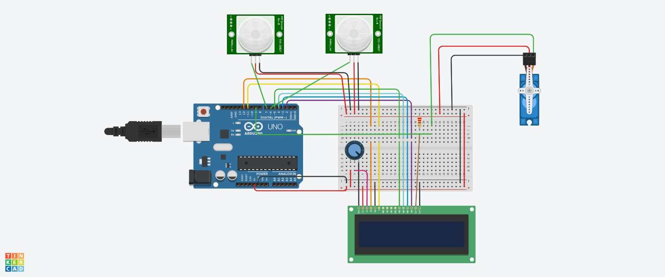

3-D Representation for Public Transport Optimization:

